Guide: Register in the system as a veterinarian.

Step 1. Click the register link in the top right corner.



Step 2. Fill up the form with your information. Note: All fields must be filled.

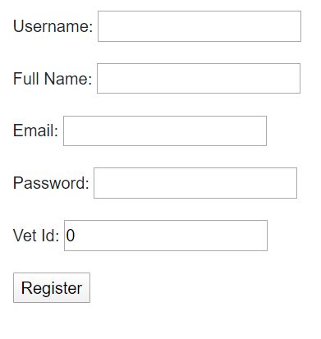

Step 3. Click the “Register” button.

Guide: Placing an order as a veterinarian

Step 1. Click Products link in the sidebar.

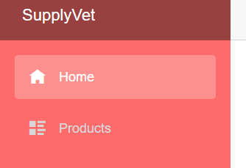

Step 2. Click a product image to navigate to the product page.

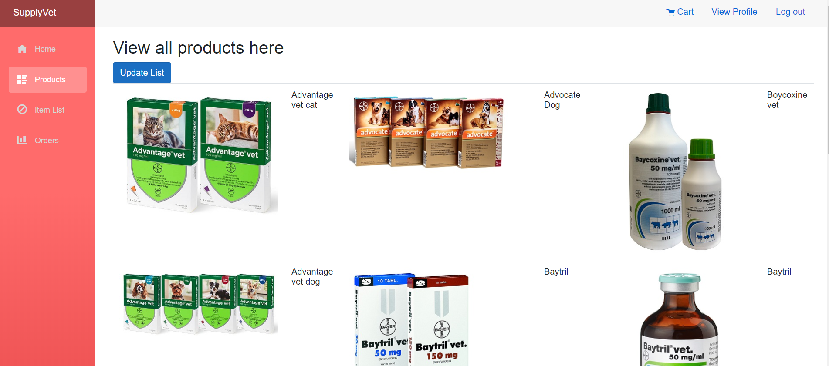

Step 3. Input the desired amount and click the “Add to cart” button in the bottom of the page.

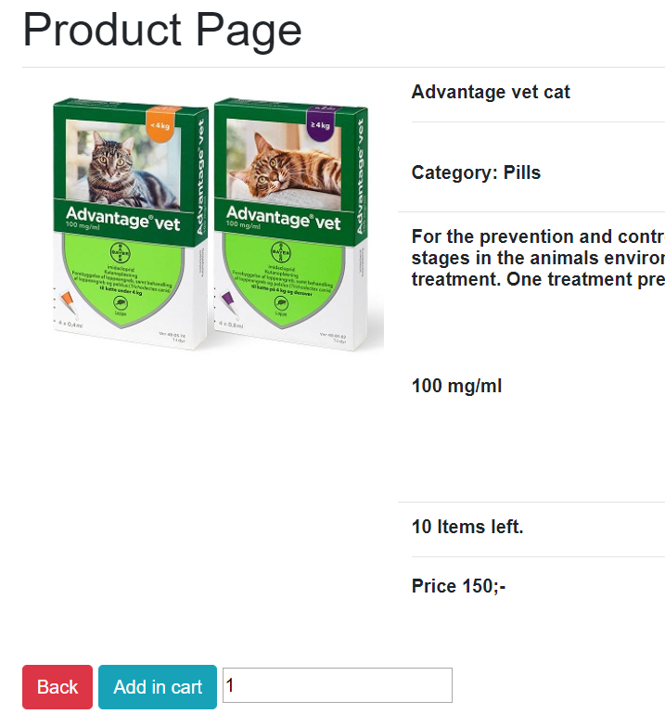

Step 4. Click the cart button on the top of the page.



Step 5. Click the “Continue to check out” button.

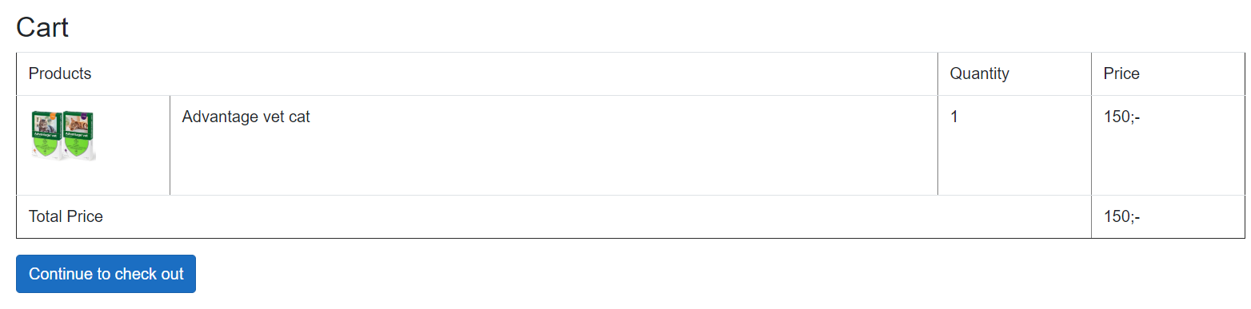

Step 6. Fill up the form and then press the “Place Order” button.

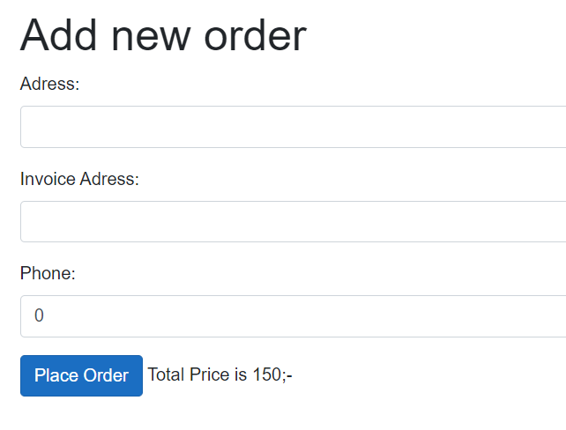

Guide: Adding a new item as a provider

Step 1. Click the item list link in the sidebar.

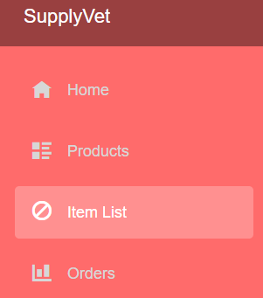

Step 2. Click the Add new item link on the top of the page.



Step 3. Fill in the form and click the “Add Item” button in the bottom of the page.

